Taslim Dosunmu

Geeth Anirudh

System Level Programming

19 September 2017

Lab 3

**Part 2: VI Editing**

1. vi RealEstate.csv
2. G
3. set number
4. ctrl g
5. :/11 E ST

577

dd

1. :50
2. :50,54s/,/;/g
3. :50,54yy

G

p

1. :50,54d
2. :1

o

Recorded in year 2008

1. esc
2. :x

**Part 3: Permissions for Files**

1. 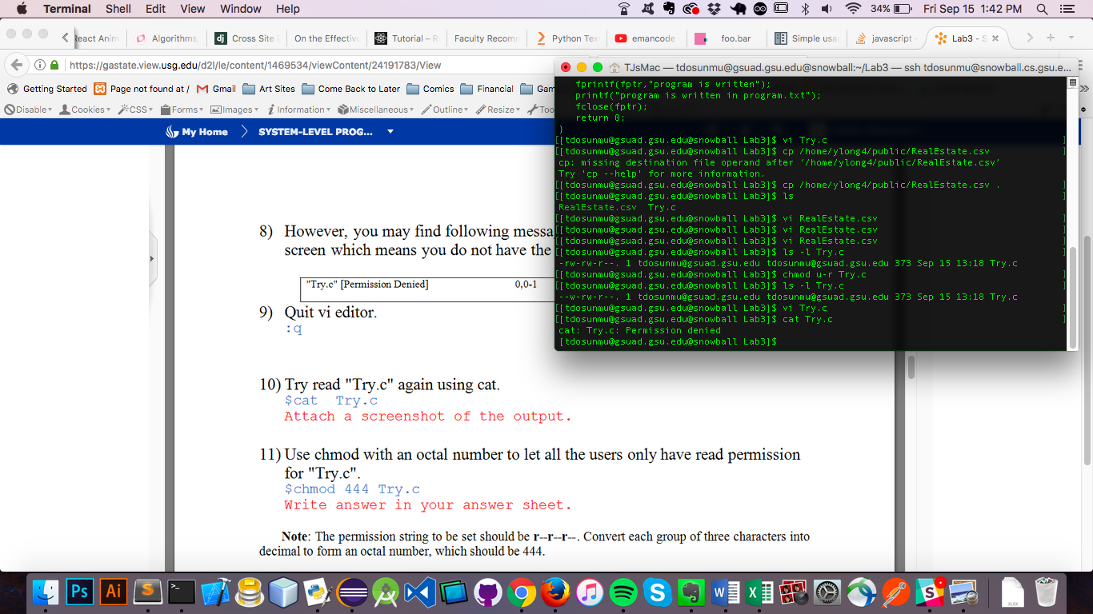
2. chmod 444 Try.c
3. r—r—r—

Users can read the file

The Group can read the file

All others can read the file

1. There is an error

E45: ‘readonly’ option is set (add ! to override)

:q!

1. chmod a+w Try.c
2. rw-rw-rw-

Users can read or write to the file

The Group can read or write to the file

All others can read or write to the file

**Part 4: Permissions for Directories**

1. 1. N
   2. N
   3. N
   4. N/A
   5. N/A
   6. N

|  |  |  |  |  |  |  |
| --- | --- | --- | --- | --- | --- | --- |
| **Owner's permissions** | **ls** | **mkdir** | **cat >** | **rm** | **cp** | **cd** |
| A. Read contents | B. Create sub-directory | C. Create file | D. Remove contents | E. Copy contents from | F. Enter into directory |
| --- | **N** | **N** | **N** | **N/A** | **N/A** | **N** |
| --x | **N** | **N** | **N** | **N/A** | **N/A** | **Y** |
| -w- | **N** | **N** | **N** | **N** | **N** | **N** |
| -wx | **N** | **Y** | **Y** | **Y** | **Y** | **Y** |
| r-- | **Y** | **N** | **N** | **N** | **N** | **N** |
| r-x | **Y** | **N** | **Y** | **N/A** | **Y** | **Y** |
| rw- | **Y** | **N** | **N** | **N** | **N** | **N** |
| rwx | **Y** | **Y** | **Y** | **Y** | **Y** | **Y** |